Alice Ferguson Foundation  Potomac River Watershed Cleanup  Phone: 301-292-5665  Fax: 301-292-1070  potomaccleanup@fergusonfoundation.org  PotomacCleanup.org |  | 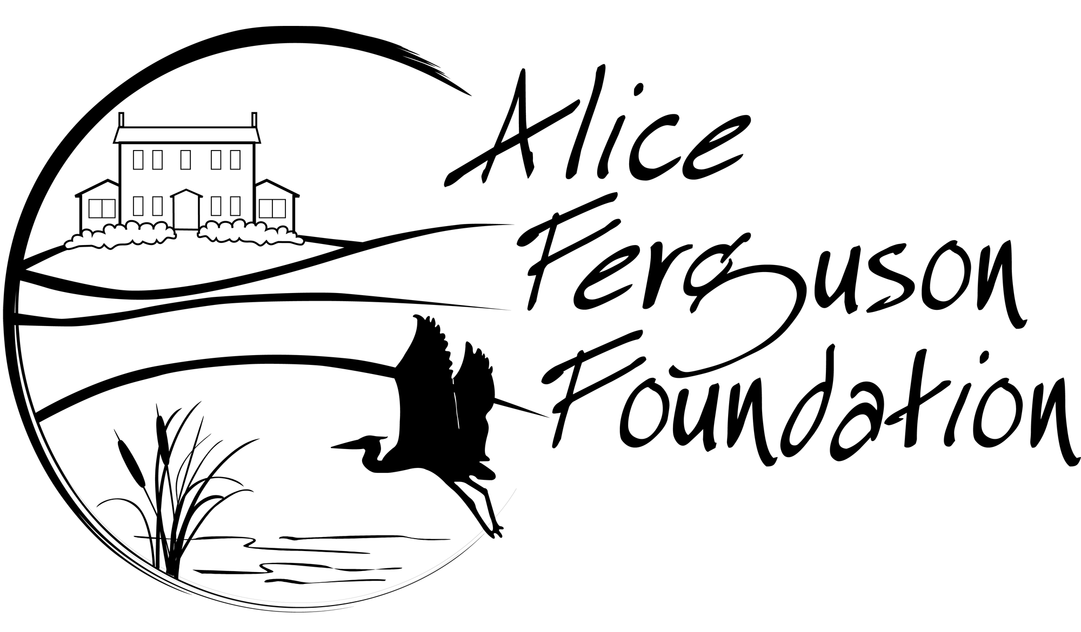 | Name___________________  Username___________________  Phone#___________________  Site Name___________________  Participating Groups or Organizations:  _______________________________
CLEANUP DATASHEET
Report results to AFF following your Cleanup

1. Trash Conditions at Site (Low, Medium, High):___________________
2. Is your site along a waterway (yes or no):_________________________
3. Estimated size of site: ________________________________________

Bulk Weight Estimates:
Kitchen sink: Porcelain 30 lbs,
Stainless steel 10 pounds
Refrigerator: 287 lbs
Washer: 125 lbs
Dryer: 125 lbs
Tires: 25 lbs or heavier
Shopping carts: 50 lbs

Category | Number
Number of Volunteers
Approximate number of volunteer hours
Non-recyclable (Landfill) Bags of trash collected
Approximate weight of trash collected
Plastic Bags Collected
Plastic Straws Collected
Styrofoam Containers Collected
Sharps/syringes Found
(please be careful and dispose appropriately)
Recycling bags of trash collected
Approximate weight of recyclables collected
Plastic Bottles Collected
Glass Bottles Collected
Aluminum Cans Collected
Tires Collected
Estimated pounds of BULK trash (Not including tires)

3. Estimated In-kind contribution from the site leader:
Hours: _____________
Mileage: ____________
Printing: ____________

4. List the top 3 brand names found:

5. Most interesting or unusual items found:

6. Did you find significant amounts of very small plastic pieces that were hard to pick-up?

7. Best quote of the day:

8. Comments, questions, or suggestions:

