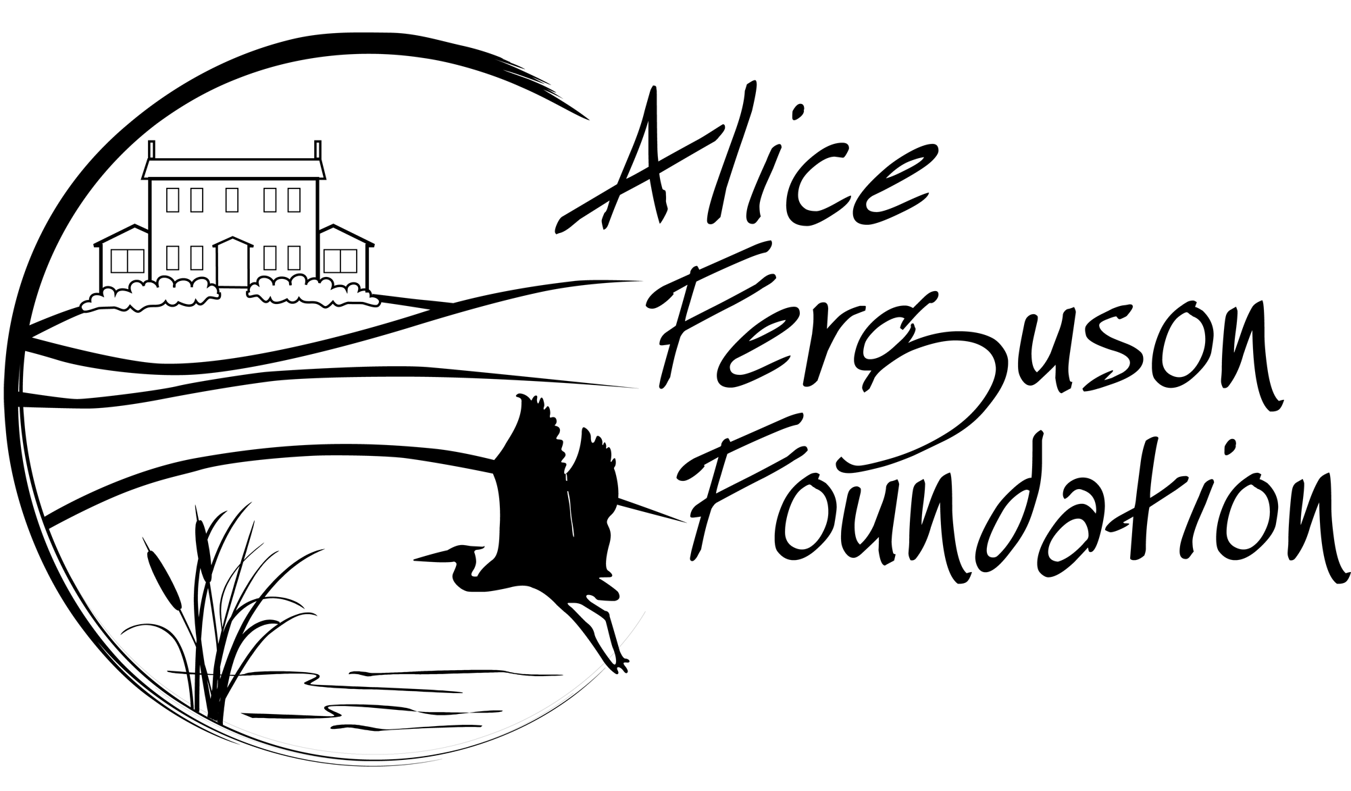
Make-a-Macro
Select adaptations to design the ultimate macroinvertebrate

Overview: Macro-invertebrates have an array of structural and behavioral adaptations that aid in their survival. Students will apply their understanding of macroinvertebrate adaptations to design the ultimate macroinvertebrate.
Lesson Characteristics:
Use the table below for lesson planning purposes:

Grade | 4-5
Time Required | 1 hour
Key Science Practices | Observation  Engaging in Argument from Evidence
Key Concepts/Terms | Adaptations
Setting | Inside
Materials | Make-a-macro Lesson Video  Make-a-macro cards, scissors, tape or glue, pencils or colored pencils (optional for coloring)

Next Generation Science Standards:

Science and Engineering Practices | Disciplinary Core Ideas | Crosscutting Concepts
Engaging in Argument from Evidence  Students observe adaptations of macroinvertebrates and their habitats and use observations as evidence that adaptations help these organisms survive. | LS4.C: Adaptations | Cause and Effect

Other Standards
Learning Objectives
Students will... identify macroinvertebrate adaptations and describe how these adaptations allow them to survive in their environment.

Preparation:
- Create cards: Students should be prepared to print the macroinvertebrate body part cards and gather scissors and tape/glue. If a printer is not available, students can use pencil and paper to design their macroinvertebrate.
- Prior to this lesson, students should have some understanding of the following: habitats (the environment where an animal lives, eats and reproduces), the difference between physical and behavioral adaptations, and predator/prey relationships.
Background Information:
- Benthic macroinvertebrates are organisms that live among stones, sediments and aquatic plants on the bottom of streams, rivers and lakes. Many are the juvenile forms of insects. Macroinvertebrates have physical adaptations suited to living in specific aquatic environments.
- Macroinvertebrate adaptations evolve gradually over several generations. Adaptations do not change simply because an individual is moved to a different environment. Instead, as the animal’s environment changes, those individuals with favorable characteristics are more likely to survive and reproduce which results in more animals with those favorable adaptations.

Vocabulary:
Term | Definition
Adaptation | Adaptations are characteristics that are outcomes of natural selection, and increase chances of survival and reproduction. Adaptations can be physiological (body parts) or behavioral (actions that increase survival).
Camouflage | A pattern, color or shape that helps a living thing blend into its environment. It can be used by prey to avoid predators or for predators to avoid being seen by prey.
Environment | Everything living and nonliving in an area.
Larva | The immature form of an insect. Some insects have a four-stage life cycle that includes egg, larva, pupa, and adult.
Macro  invertebrate | Any animal lacking a backbone and large enough to see without the aid of a microscope.
Niche | All of the interactions of a species with the other members of its community, including competition, predation, parasitism, and mutualism. Informally, considered the “job” or “role” that a species performs within nature.
Observation | The action or process of obtaining information about something or someone by carefully watching or examining it.
Predator | An organism that eats other animals.
Prey | The organism the predator eats.

Procedure:
Follow the steps in the table below to conduct the activity.
Sentences in bold are suggestions for what an educator might say to students.
Items in italics are possible student answers to questions.
Step | Action
5E’s: Engage Learning Cycle: Invitation
1 | Prior to watching the video, prompt students with the following: All animals have adaptations. Can you think of some adaptations of dogs and cats?  Eyes that are adapted for night-time hunting.  Claws for hunting.
2 | Choose an animal that is commonly see on school grounds to start the following discussion (like a squirrel or bird).  Let’s consider squirrels: list the characteristics of the habitat for this animal.  Trees, grass, rocks, bugs, birds. Possible predators: cats, raccoons, hawks. Their habitat is cold at night and warm during the day.
5 E’s: Explore Learning Cycle: Exploration
3 | Now that we have described the environment, how does this animal use adaptations to survive in its environment?  If students have difficulty answering this question ask:  How does the animal get food?  How does it built or find shelter?  How does it avoid or defend itself from predators?  A squirrel uses claws to climb trees.  A squirrel eats nuts, leaves, roots, seeds, and has four front teeth that never stop growing so that they don't wear down from the constant gnawing.
5 E’s: Explain Learning Cycle: Concept Invention
4 | Watch the video to observe macroinvertebrate adaptations.
5 E’s: Elaborate Learning Cycle: Application
5 | Ask students to look over the Make-a-macro cards.  Direct students to choose parts from the set of cards to assemble their macroinvertebrate. Remind them to consider how each part they choose will help their macroinvertebrate to survive.  Students should assemble their unique macroinvertebrate and answer discussion questions. Students may choose to print the cards and assemble, or they can draw the chosen parts on a separate piece of paper.
5 E’s: Evaluate Learning Cycle: Reflection
6 | Have students select and research a real macroinvertebrate. They should explain what adaptations this macroinvertebrate has and use evidence to argue how it helps the animal survive.

