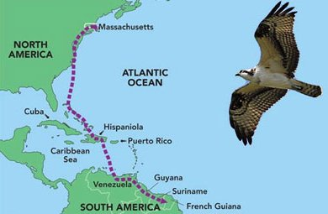
Migration Game
Materials – 24 station cards with stands, osprey/swan cards, bands in blue box, 12 dice data sheet with clipboard and pen (in a bag in Larry’s office).
Set-Up – place 24 stations in semi-circle far enough from each other they don’t interfere with each other. Set up home base with cards, clipboard. Place 2 die at Stations 1, 8, 9, 10, 14, 17. Place blue box with bands at Station 6.
Intro: I’m here today to talk about migration. Can anyone tell me what migration is? Because migratory birds travel such long distances, they can encounter some obstacles along the way. Some birds never make it to their destinations due to the challenges that they face while trying to make the trip.
- Each student will become a local migratory bird for our game. You will either be an osprey or a tundra swan. There is more information about your bird on the back of the cards. You will also be either male or female based on what you are as a human.
- You will be starting here and migrating to there, but you won’t necessarily stop at each station. When you do arrive at a station, there will be a card that you need to read. You will complete the actions on the card before moving on to the next station.
- Some of the stations have dice that you will need to roll to find out how many stations to move forward. Some tell you on the card how many stations to move forward. Please be sure you return the dice to the station before you move on.
- There is one station where a scientist might “band” you, this allows scientists to track where a bird travels to. It does not affect the bird or their migration.
- As each student returns, we will be tracking your information.
As each student starts the game, randomly hand them either an osprey or swan card. As each student returns, collect their bird card and their data and if they have a band, ask them to return it to the band box at Station 6.
When everyone has come in, ask them to raise their hands if they lived and then, if they died. Ask some of the students to share how they died with the group. Let’s look at the actual numbers by looking at our data sheets. Quickly add up the numbers and tell them how many swans survived both male and female. Ask them if they think enough birds survived to be able to reproduce and make the trip back? Then add up the ospreys male and female. Ask them if they think enough birds survived to be able to reproduce and make the trip back? Ask them “what would happen if only females (or males) survived the migration?” Would the birds survive then? Ask them if they can see how challenging it might be to be a migratory bird.

