BIODIVERSITY
The variety of life forms in a given area.
More variations equal a healthier, more stable environment.

VERY DIVERSE  Wide variety of plant and animal species means a healthy, stable environment that offers many options for food and homes. | 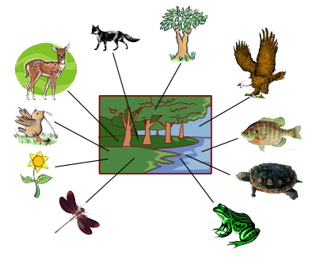
LESS DIVERSE  Little variety of plant and animal species means a less than healthy environment that is out of balance, offering fewer options for food and homes. | 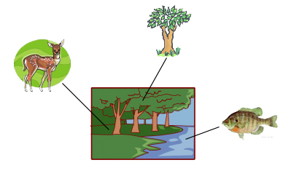
MONOCULTURE  (Only one species – grass)  Very little variety of plant and animal species means an unhealthy environment that is out of balance, with almost no options for food and homes. | 