Composting
Composting- Composting is the decomposition of plant remains and other once-living materials to make an earthy, dark, crumbly substance that is excellent for adding to house plants or enriching garden soil.
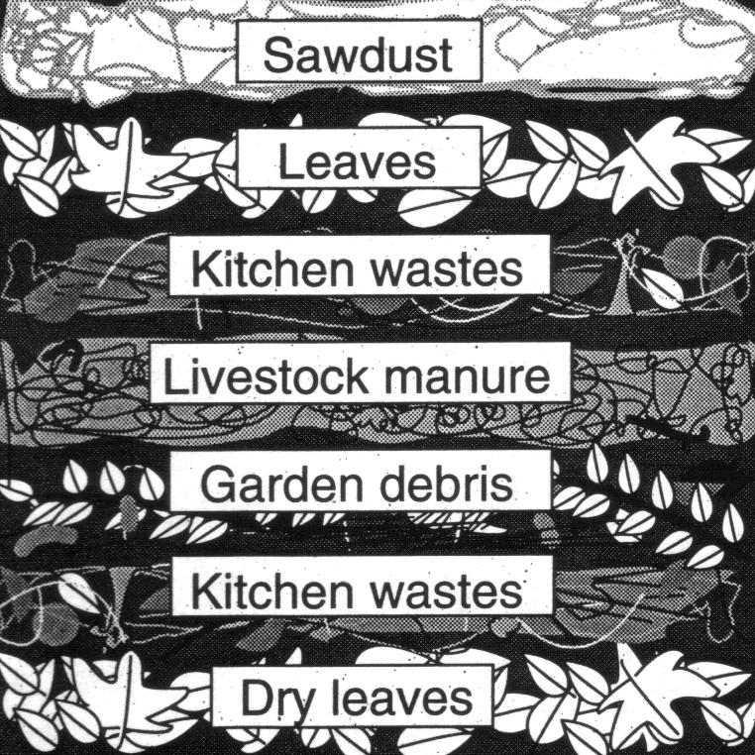

How to Do It – People compost in small and large areas, often in their backyards. This reduces the trash sent to the landfill, and creates great soil for plants. Look at the table below to see what to include in a compost pile.
Component | Amount | Examples
Carbon Source | 2 parts | dry leaves, chopped woody stems, straw, sawdust, or other dried plant matter
Nitrogen Source | 1 part | moist kitchen scraps, young weeds, grass clippings, manure from plant-eaters
Air | enough air for aerobic organism survival | layering materials and turning the pile from time to time adds oxygen needed for aerobic organisms to survive
Microorganisms | Soil sprinkled throughout your pile will give you all you need. | earthworms, bacteria, fungi, sow bugs, etc.
Water | moist, but not soggy | N/A

