Ecosystem Food Web Mural Scoring Rubric

How You Will Be Graded | Your grade will be based on the criteria in the table below. Next to each criteria are four columns:  - How many points each topic is worth;  - your score of your own work;  - how another student (peer) scores your work; and  - the teacher’s score of your work.

 | Assessment
Grading Criteria | Possible Points | Self | Peer | Teacher
DIAGRAM is complete and shows clearly what the organism looks like
HABITAT is correctly explained on information card
SIZE: Correct size is on information card
FOOD: Correctly explained what the organism eats/how it gets energy
PREDATORS: Correctly explained what eats the organism
REPRODUCTION: Correctly explained how and where the organism reproduces
CLASSIFICATION: Correctly identified the KIND of organism
PRESENTATION: Clearly communicated all information to the class
MURAL PLACEMENT: Put organism drawing in a place that shows where the organism lives in the habitat.
FOOD CHAIN CONNECTION: Correctly connected the organism to something that eats it in the mural | 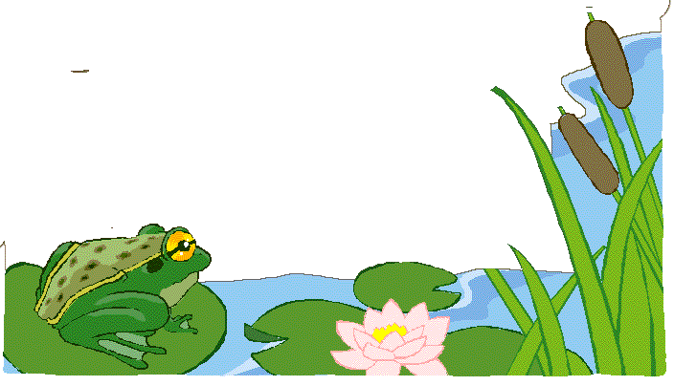
PART D: Drew a complete food chain that includes their organism.
PART E: Correctly Answered Questions in Part E of the Student Sheet
TOTAL SCORE

