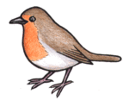Eat Like a Bird

Observation

What does your beak look like?

Draw a picture of your beak:

What kind of bird has a beak like yours?

Hypothesis

What do you think your beak is adapted for doing?

What food source do you think you’ll get the most of?

Data Collection

|  |  |  |
| --- | --- | --- |
| Food source | How many/much food did you collect? | What is this food source in the wild? |
|  |  |  |
|  |  |  |
|  |  |  |
|  |  |  |
|  |  |  |

Results

What did you get the most of?

What did you get the least of?

Analysis

Do your results match your hypothesis?