The Energy Cycle: Food Chains/Food Webs
Food Chain- The path of food energy from one organism to the next.
Sunlight Plants/Algae Herbivore Omnivore Carnivore
Source of Producer- Primary Consumer Secondary Consumer Tertiary Consumer
Energy Green plants make Eat only plants/algae Eat plants and animals Eat only animals
their own food using energy from sunlight
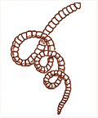

Decomposer
Breaks down dead plants and animals and returns nutrients to the soil

Food Web - All feeding relationships in an ecosystem. A food web is many individual food chains together. Arrows point in the direction of energy flow.
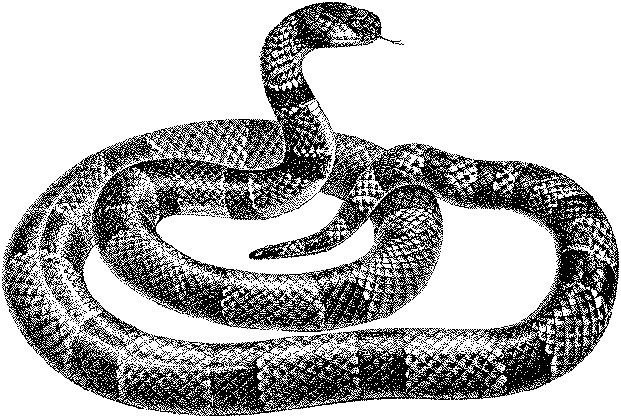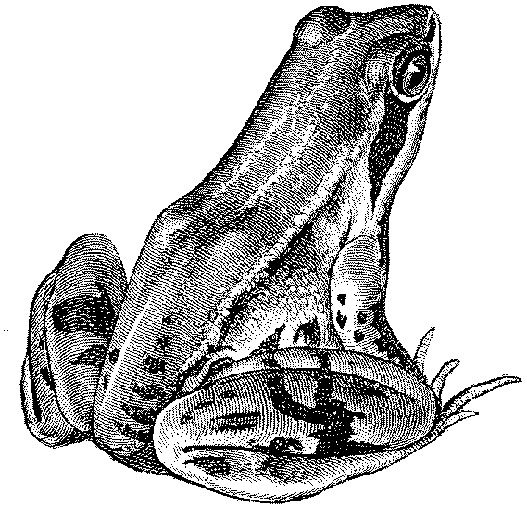
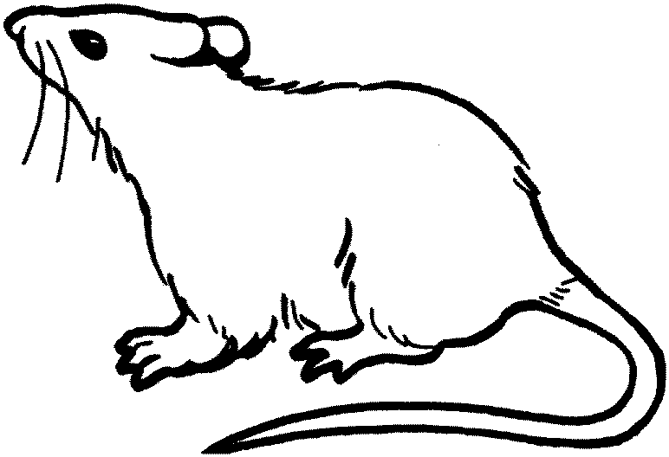
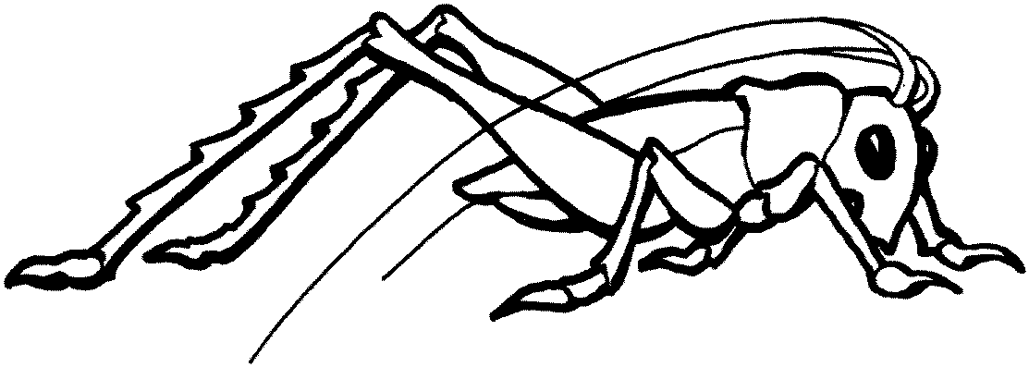

Decomposer
Breaks down dead plants
and animals and returns nutrients to the soil.

