Erosion

Erosion- Movement of soil by water or wind.

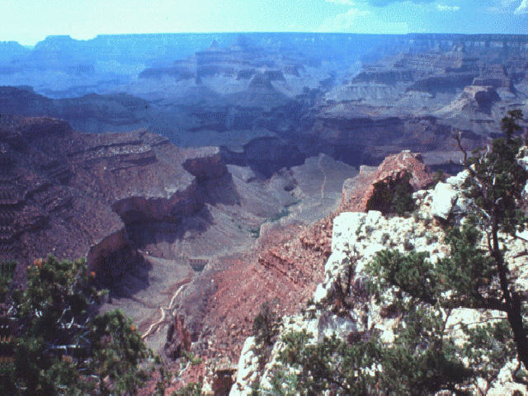
Weathering is the breaking down of rocks into soil. These small particles can then be eroded by wind or water.
Natural weathering and erosion have formed the Grand Canyon.

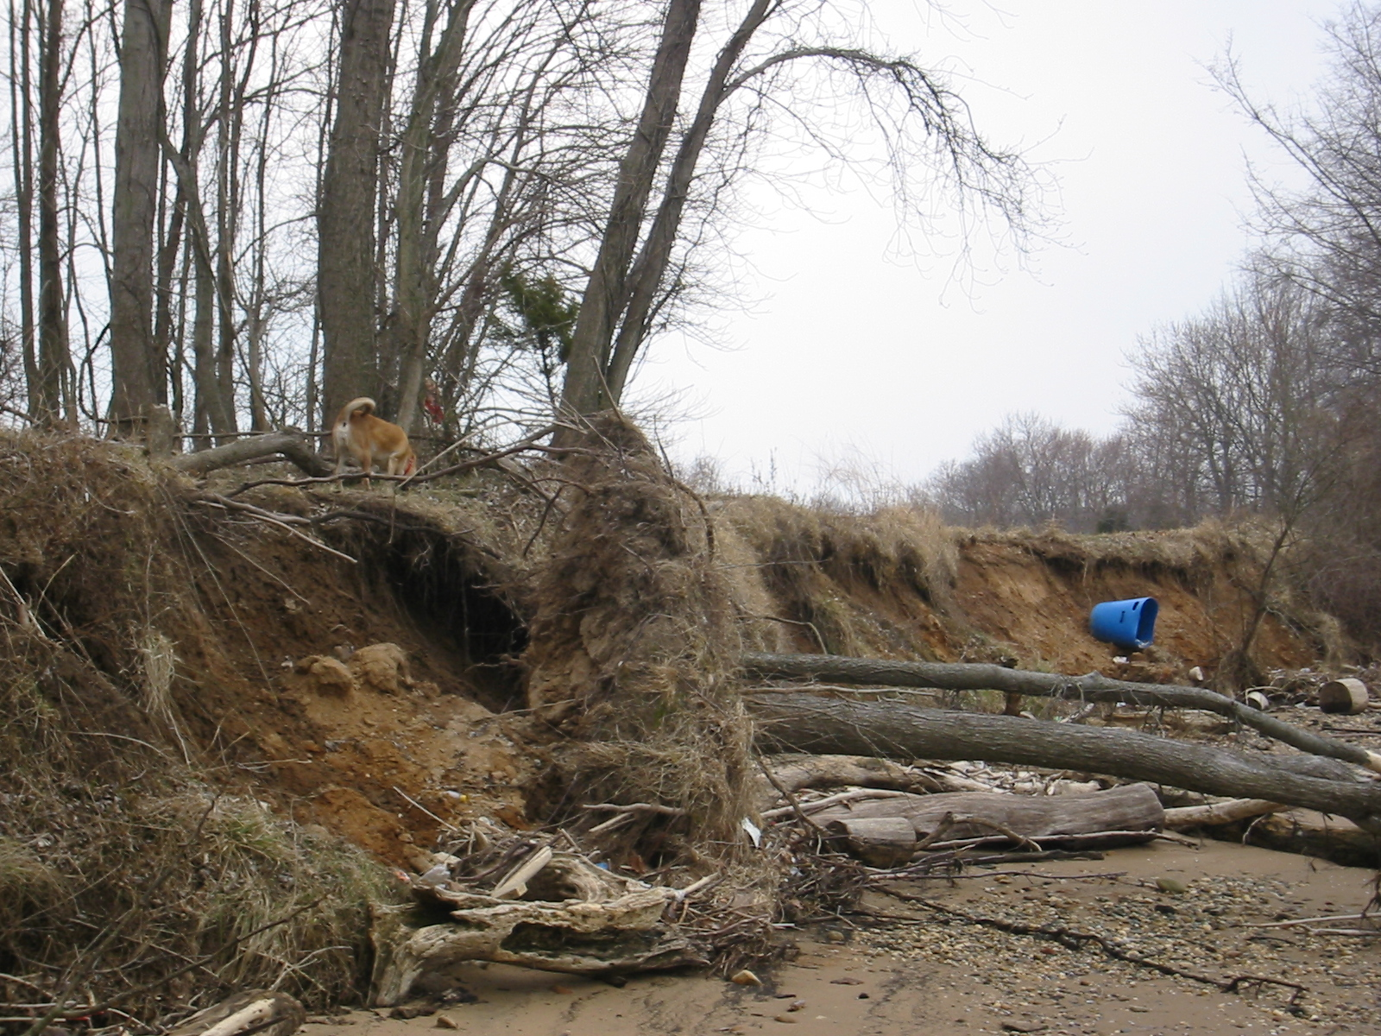

Humans have increased erosion along the banks of rivers by clearing land for agriculture.

We can slow erosion along streams and rivers by:

• planting buffer zones of trees and other plants with deep roots to hold soil in place

• placing physical barriers such as sea walls or rip-rap (rocks) to protect against wave action

