PREDATOR – PREY

Predator: an animal that hunts, kills and eats other animals

Prey: an animal that is hunted and killed for food by another animal

Some prey animals are food for more than one kind of predator.

Example: hawk and cat eat mouse as shown in the diagram below, arrows show energy transfer as predator eats the prey

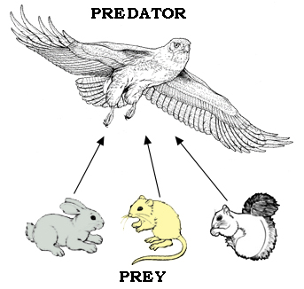 | 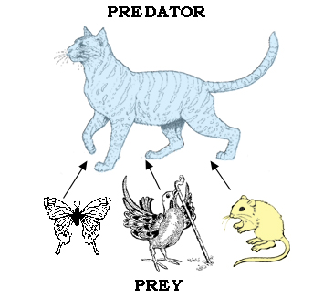
Some predator animals become prey to larger predators.

Example: cat is predator when it eats bird in diagram above, cat becomes prey when eaten by fox as in the diagram below

