
Q Values
A Means of Weighting Water Quality Test Values

Overview | To develop the Water Quality Index (WQI), the National Sanitation Foundation selected 142 people who represented a wide range of positions at the local, state and national level.  The scientists graphed the level of water quality ranging from 0 (worst) to 100 (best) from the raw data for each of the tests. For example, for stream health, the best value for pH is about 7.4, so it is given a Q-value of close to 100. Low and high pH values do not support stream health and were given lower scores. The curves drawn by each scientist were then averaged to obtain a weighting curve for each parameter. Results of the parameters are compared to the curves, and a numerical value, or “Q-value” is obtained.

Calculating Q Values | Compute Q-values for each parameter as follows:  - Find the weighting curve graph for your test.  - Mark your test result with a pencil on the X-axis (horizontal) of the weighting curve graph.  - Draw a vertical line from that point to the weighting curve. Then draw a line from the intersection point on the curve to the Y-axis (vertical) of the graph. The point where your line intersects the Y-axis is the Q-value for your test result.

Dissolved Oxygen
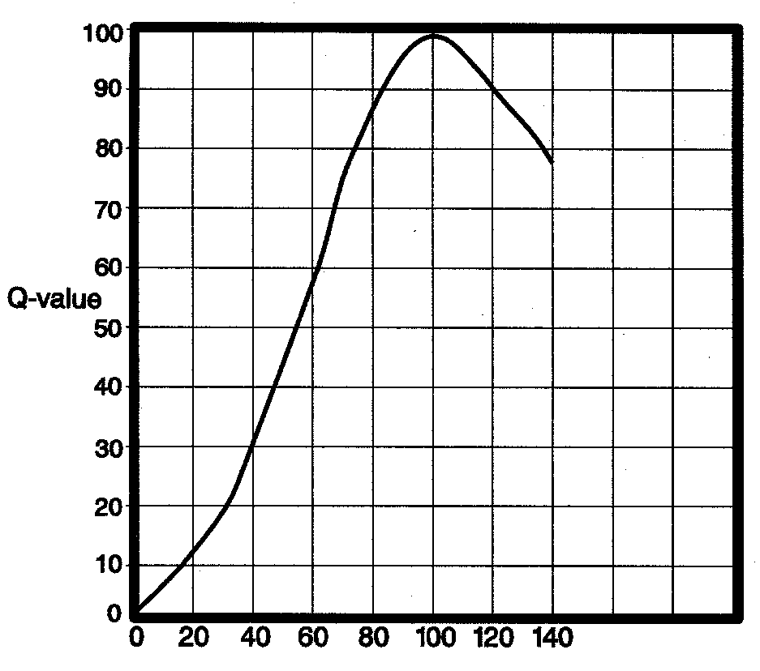
Dissolved Oxygen: % saturation
Note: Q = 50.0 if DO% saturation >140.0

pH
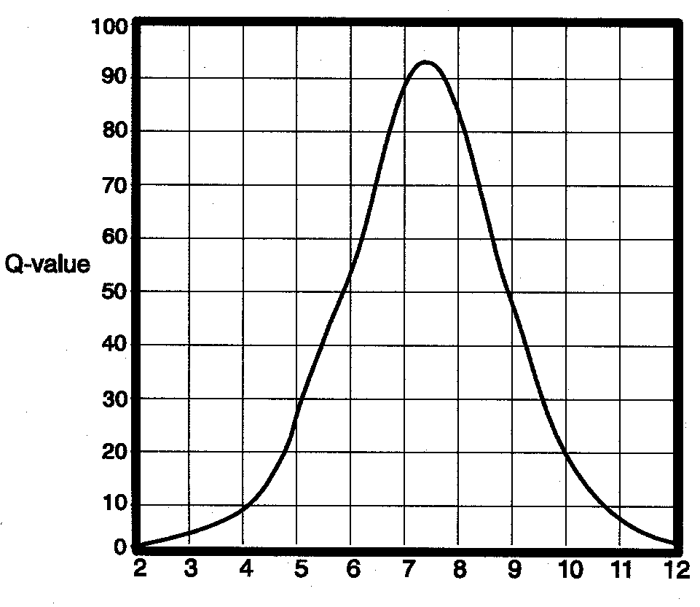
pH: units
Note: Q = 0.0 if pH < 2.0 or if pH > 12.0

Q Values, Continued

Orthophosphates

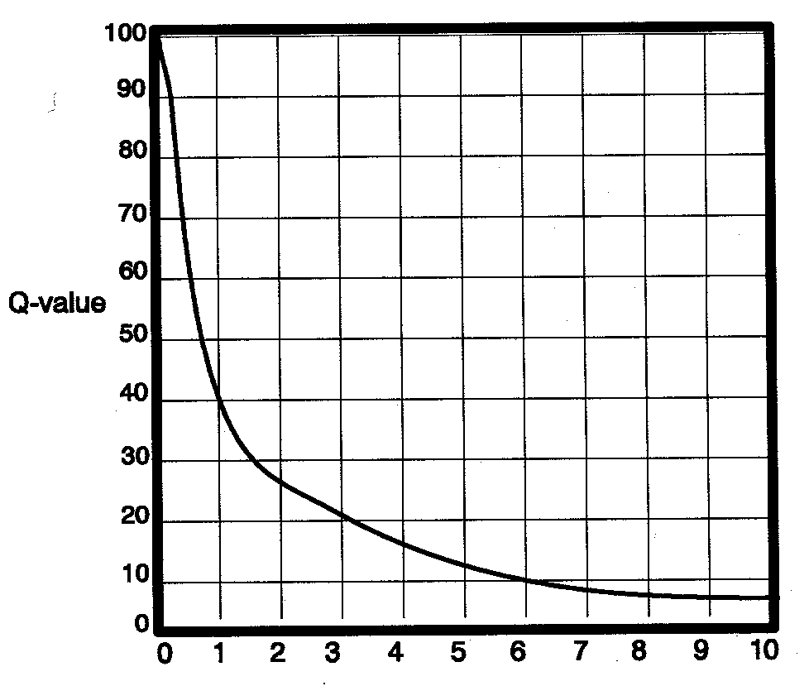
Orthophosphate: mg/L
Note: Q = 2.0 if orthophosphate > 10.0

Nitrates

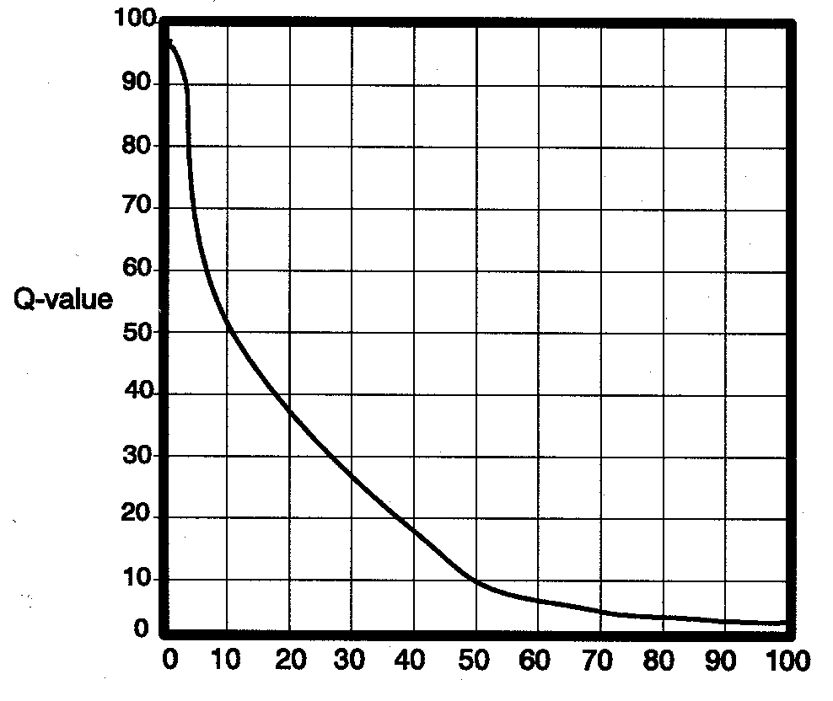
Nitrate mg/L

Note: Q = 1.0 if Nitrate > 100.0
: m

Turbidity

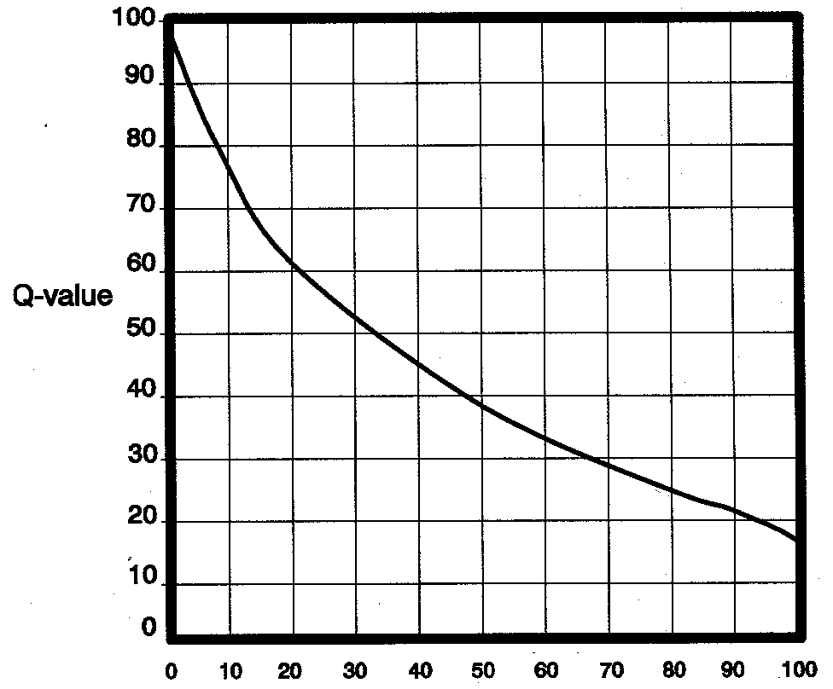
Turbidity: JTU
Note: Q = 5.0 if Turbidity > 100.0

