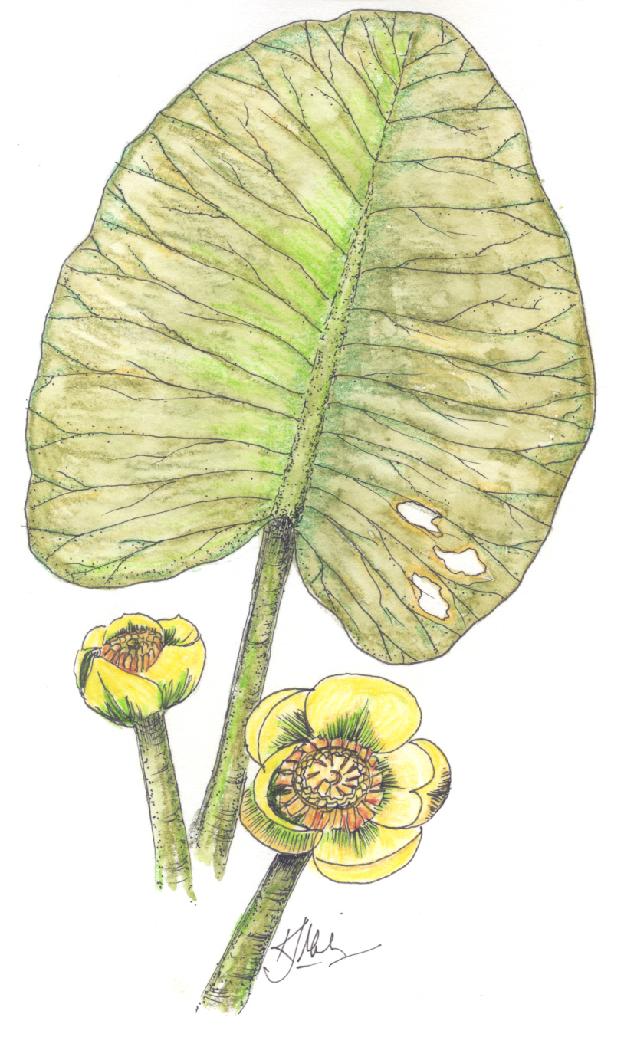
Student Sheet for SEDIMENT: Choking the Life Out of the Bay

Introduction | When rain hits bare soil, it loosens it, carrying the soil downhill to the nearest river, stream or bay. This is EROSION. In this activity, you will construct a model of the Chesapeake Bay to see how one of the worst pollution problems, SEDIMENT (soil), affects aquatic life (things that live in the water).

Objectives | After completing this activity, you should be able to:  - Give 3 examples of how and why SEDIMENT in water is dangerous to aquatic organisms.

Materials | Your group should have:  - 2 clear jars, with lids (same size/type)  - Equal amounts of water for each jar, above  - 2 plastic plants  - Soil (1 cup)  - Dried beans  - Noodles  Note: You may have additional items, which your teacher will explain.

Procedure | Follow the steps and instructions below to conduct the activity.

- In the space below, describe 3 ways you think SEDIMENT affects the plants and animals in the Chesapeake Bay.

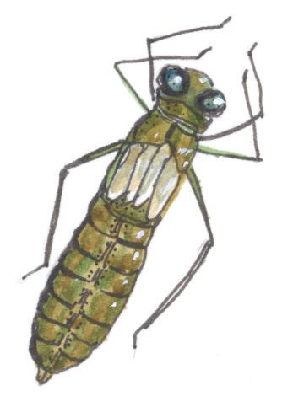
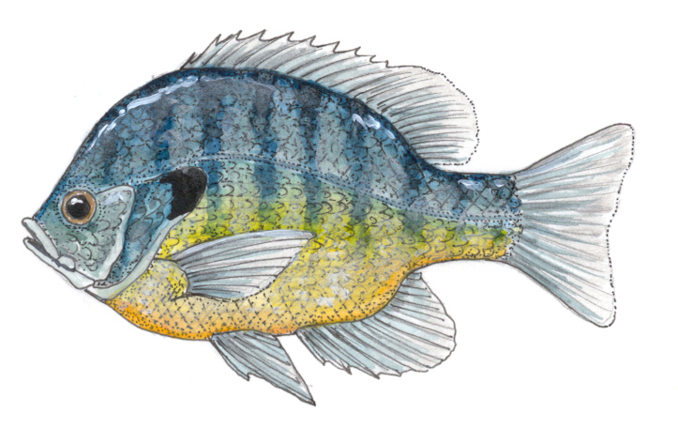

Continued on next page

Student Sheet for SEDIMENT: Choking the Life Out of the Bay, Continued
- Using the all of the materials EXCEPT SOIL, construct two identical bays, one in each jar. These jars are models of the Chesapeake Bay, and you may use the beans, noodles, etc. to represent animals living in the bay. List the items you included, and what animal/plant each one represents in the table below:

Object You Used | Organism that It Represents

- In the space below, draw a diagram of each of your “Bays.” Label the organisms you are representing in each of your jars.
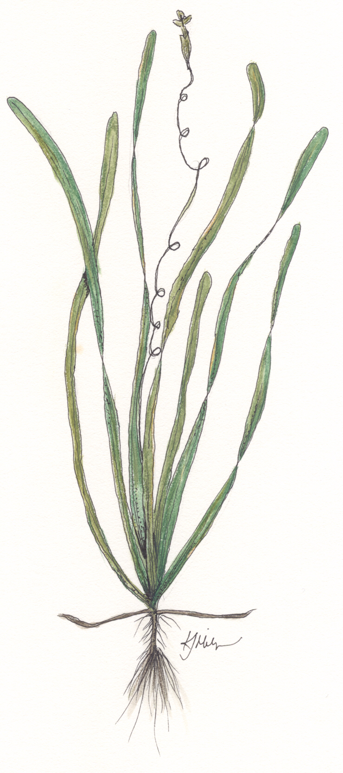

Continued on next page

Student Sheet for SEDIMENT: Choking the Life Out of the Bay, Continued
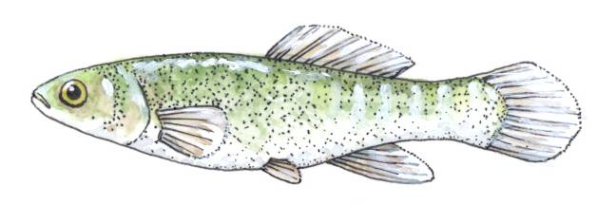
- Add a handful of soil to one of your jars. Cap and shake the jar.

- Let the jars sit for 5 minutes. While you are waiting, complete Steps 6-9.

- Compare the two jars. What differences do you notice? List at least four differences here.

- Through which jar could sunlight pass most easily? To which organism(s) in your jar would sunlight be most important? Explain why.

- Read the following paragraph on how sediment pollutes the water from the book Turning the Tide, and answer Question 9.

“Sediment pollutes by smothering fish eggs, by tearing at fragile gills of young fish, and by covering gravel bottoms that are prime habitats for spawning fish and aquatic insects. Further downriver, it may cover oyster beds. Sediment also clouds the water, blocking sunlight need to grow the submerged grass that is critical habitat in streams and the bay (Horton & Eichbaum, 1990).”

- Describe at least two ways that you think the submerged grass mentioned in the paragraph is important to animals living in the Bay.
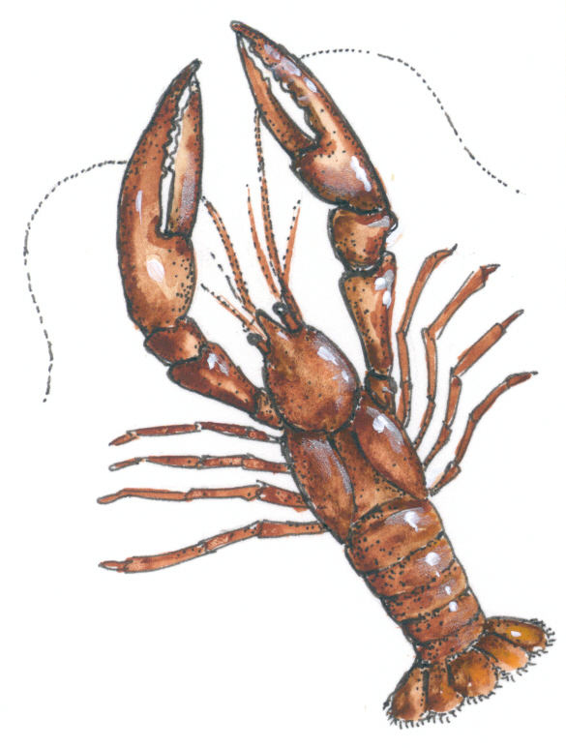

Continued on next page

Student Sheet for SEDIMENT: Choking the Life Out of the Bay, Continued
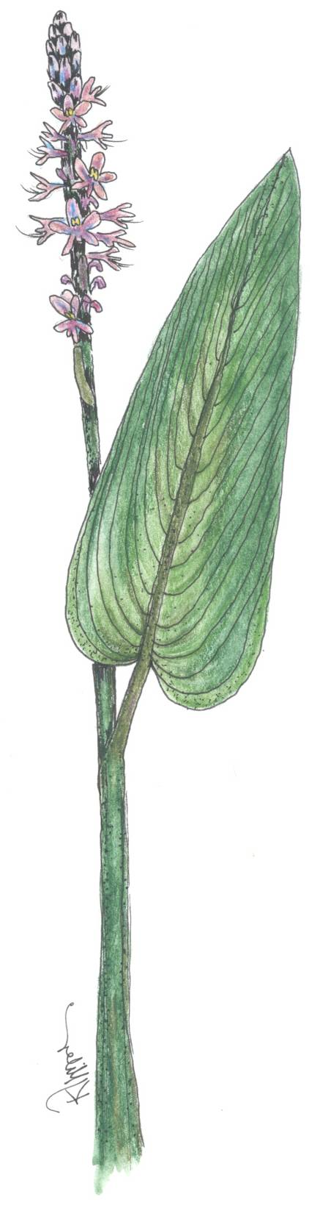
- After the five minutes are up, observe the two jars again. In the space below, draw and label your two jars, noting any changes that occurred.

- Based on your observations and the reading, summarize, in the table below, how sediment affects each type of aquatic life represented in your jar. How does sediment affect the organisms differently when it is suspended in the water, versus when it has settled on the bottom? How does sediment affect the organism’s food chain?

Bay Organism | Effect of Sediment
