Sedimentation
Sedimentation- When loose materials such as rock fragments/soils are transported by wind, water or glaciers and deposited in an area.

Causes of Sedimentation:
The main cause is soil run-off from
agricultural fields.

Problems of Sedimentation:
- Decreases water depth
- Kills/injures plants and
animals by covering them.
- Reduces overall water quality

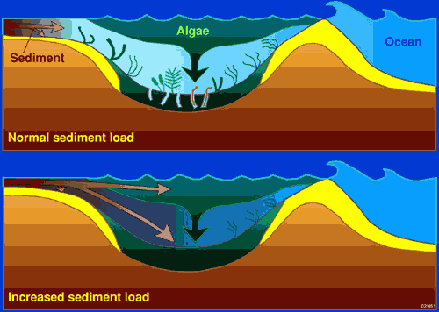
Picture courtesy of Hodgkin, E. P. and Hesp, P. 1998

The first picture to the left shows a normal stream/bay.

The second picture shows how increased sediment covers plants and animals, killing them, and resulting in poor water quality.

Ways to slow sedimentation:
- Plant trees or green plants between agricultural fields and water bodies (these are called buffer zones).
- Build physical barriers such as sea walls or rip-rap (rocks) to hold soil in place.
- Use farming techniques that reduce soil erosion and sedimentation.

