Soil
Soil- A mix of minerals, organic matter, water, air, living things and chemicals.

It’s not just dirt! Think of it as a thin living skin that covers the earth.

Soil has LIFE-insects, plants, animals, fungus and bacteria.

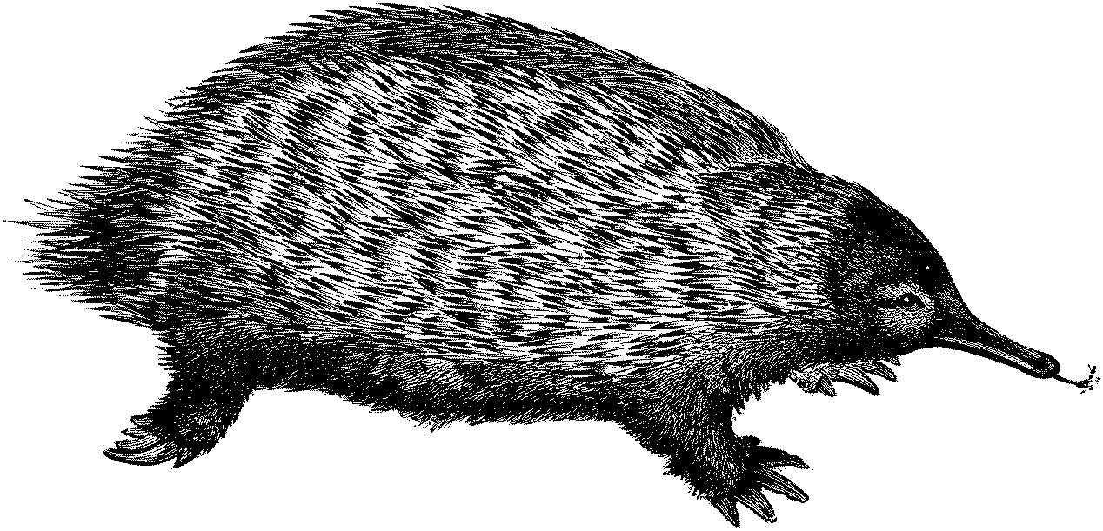
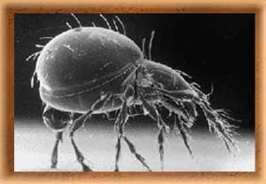

Eastern Mole Beetle Mite

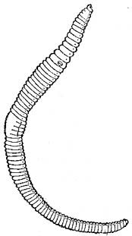

Amoeba
Earth Worm

Root Fungus

Soil acts as a FILTER to make clean water.

Soil RECYCLES dead and decaying plant and animal (including human) materials.

Soil has LAYERS like pizza:

Ground Level and Topsoil (the toppings) where plants grow.
Subsoil (the cheese) where roots dig to find water and nutrients.
Weathered Partent Material (the sauce) is minerals, rock particles and nothing living.
Bedrock (the crust) is solid rock!

