Water Quality Parameter Fact Sheet –TURBIDITY
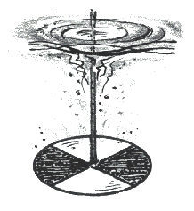
Student Background Information

What is Turbidity? | Turbidity is a measure of the cloudiness of water, caused by fine  particles, such as silt, that are suspended in water.

When is it a Problem? | Water clarity is important for underwater plants, which need light for photosynthesis (making food). When water is cloudy or “turbid,” less light can reach plants growing on the bottom.  In extreme turbidity, this excess sediment can clog the gills of fish, making it harder for them to breathe. These particles of sediment may even smother fish eggs and macroinvertebrates (tiny aquatic creatures).  Turbidity may also cause higher water temperatures because the suspended particles absorb heat. This, in turn, means less dissolved oxygen (DO) in the water because warm water holds less oxygen than cold water.

Causes of Too Much Turbidity | Erosion is a natural process that forms land such as the Grand Canyon, but often human activities speed up this process, which puts excess soils into our rivers and streams (SEDIMENTATION).  Causes of increased erosion include:  - Construction of new homes, schools or businesses, which may remove trees and leave large areas of exposed soil that washes away in rain and snowmelt.  - Farms where fields are left exposed after a harvest.  - Cutting of forests for lumber, paper, etc., which leaves soil exposed to rain and snowmelt.

Units of Measurement | Turbidity is measured in Jackson Turbidity Units, or JTU’s.

How Much is Too Much? | In a stream, turbidity higher than 40 JTU’s in unacceptable, as this can damage gills of fish.  Drinking water should have a turbidity of less than 5 JTU’s.

