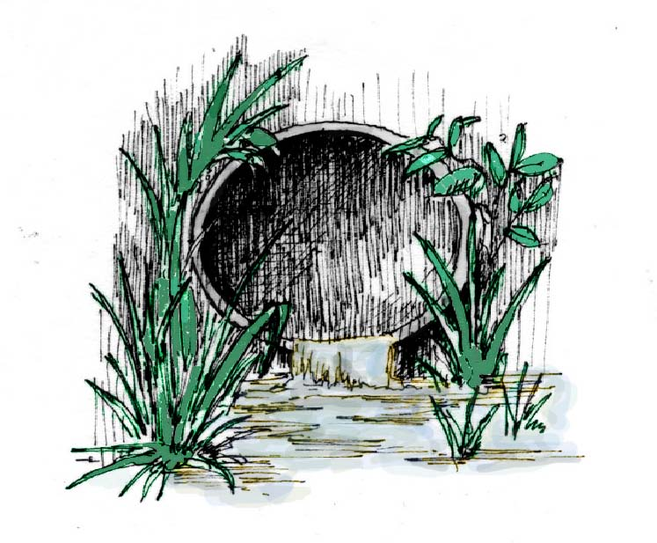
Water Quality Parameter Fact Sheet -- pH

What is pH? | pH measures how acidic or basic something is. Lemon juice  is very acidic, and ammonia is very basic. Water that is healthy for living things is in the middle, not too acidic or too basic.

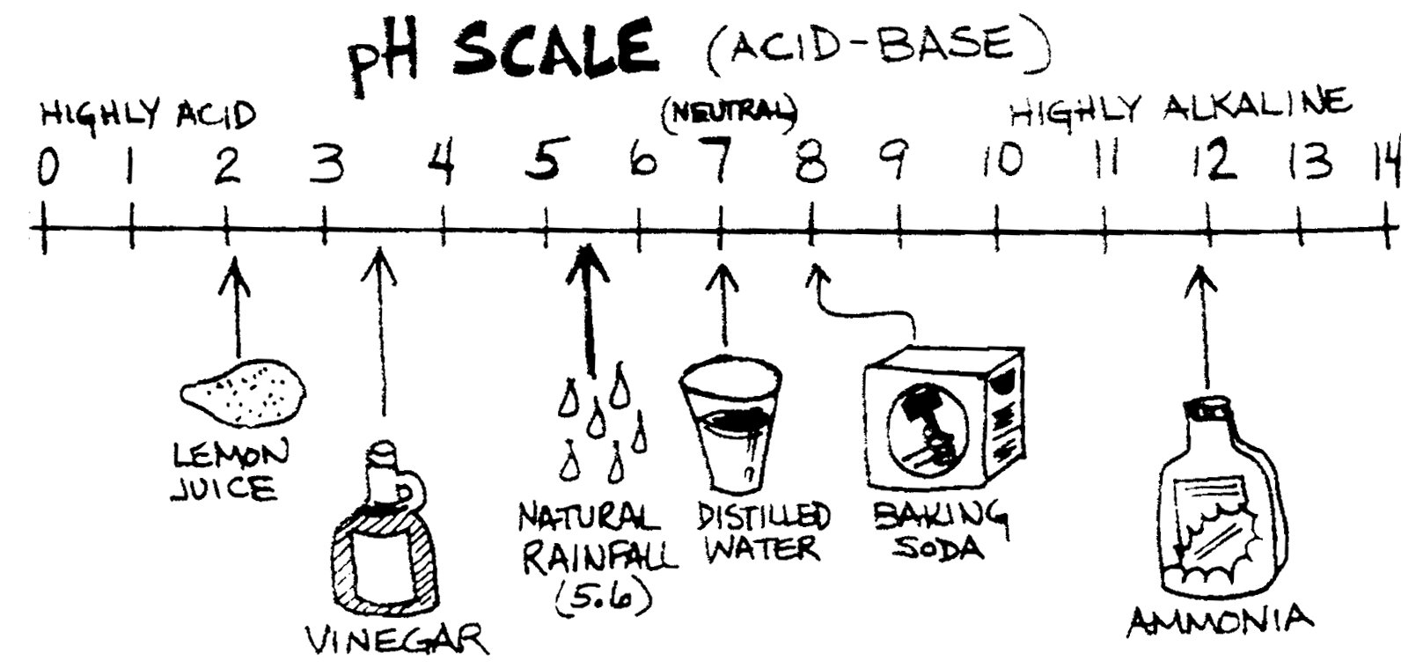  How is pH Measured? | pH ranges on a scale from 0 – 14, and there are no units of measurement. 7.0 is considered neutral. Below 7.0 is considered acidic, and the closer it is to 0, the more acidic the substance is. The opposite is true for basic substances: above 7.0 is basic, and the higher the number the more basic it is.  A sample scale is shown with common items below:

What is a Good pH for Water Quality? | Aquatic organisms can usually tolerate a pH from 6.5 to 8.5.

What Causes pH Problems in Our Water Bodies? | Many factors can affect the acidity of aquatic ecosystems. Some of these are:  • Acid rain,  • Minerals that dissolve out of rocks,  • Melting snow,  • Heavy precipitation, and  • Accidental spills, agricultural runoff, and sewer overflow.

