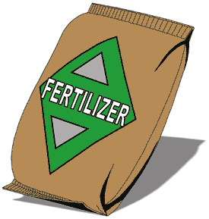
Water Quality Parameter Fact Sheet –Phosphates
Student Background Information

What is Phosphate? | Phosphates, are essential for life to all plants and animals,  whether they live on land or in the water. In most natural  bodies of water, phosphate is present in very low concentrations. In aquatic  ecosystems, plants compete for phosphates. Thus, plant growth and reproduction  will be limited by the amount of phosphates available.

What is the Problem? | When there is too much phosphate:  - Microscopic green plants called algae reproduce rapidly in “algae blooms.” This means that the water is covered with algae, and  - No sunlight can reach plants on the bottom, so they die, and this reduces the DO in the water.  - Also, when the algae have used up all of this excess phosphate in their rapid growth, they begin to die off.  - As the algae and other plants die, they use up all of the dissolved oxygen in the water as their bodies decompose.  - This means the fish and other animals in the water suffocate, and the whole aquatic ecosystem collapses.

Causes of  Too Much Phosphate | The most common reasons for excess phosphates are:  - too much fertilizer put on our lawns or farm crops;  - detergents with phosphate water softeners in them; and  - some industrial wastes.

Units of Measurement | Phosphates are measured in mg/L, or milligrams of phosphate per liter of water.

What is a Good Level for Phosphates? | In natural bodies of water, a phosphate level of 1.0 mg/L is considered excellent.  Levels of 2-3 mg/L contribute to increased plant growth and algal blooms.  Levels of 4.0 mg/L and higher are quite likely to trigger an algal bloom.

