Student Sheets -- What Macroinvertebrates Can Tell You About Stream Health

Think About It | Have you ever sat by a stream or ditch and seen dragonflies flitting about?  Or wondered why there always seem to be more mosquitoes when water is nearby?  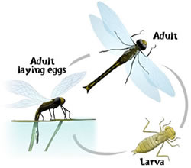  Or watched spider-shaped insects walk upon the surface of a pond or even a puddle, seeming to dance to a rhythm only they can hear?

How Insects get from Water to Land | Many insects lay their eggs in water. The young (immature)  insects grow and develop in water. When they are mature and  are ready to become adults, they go through a great body-shape  change, called METAMORPHOSIS. After this change, some  may stay near water to eat and mate, but they no longer live in water. Examples of aquatic insects that spend the first part of their lives in water include dragonflies, stoneflies, and mosquitoes.

Why Should We Care? | Aquatic insects are an important part of the  FOOD WEB.  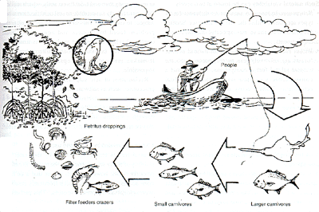  MACROINVERTEBRATES are large enough to be seen with the naked eye (macro) but lack a backbone (invertebrate). They inhabit all types of running waters, from fast-flowing mountain streams to slow-moving rivers. Examples of aquatic macroinvertebrates include insect larvae, crayfish, clams, snails and worms.

Student Sheets -- What Macroinvertebrates Can Tell You About Stream Health, Continued

What Macros Tell Us About the Water Where They Live | Macroinvertebrates are good INDICATORS of stream quality because they:  • vary in sensitivity to the physical, chemical, and biological conditions of the stream;  • tend to live in one spot, and can’t easily escape pollution;  • are a critical part of the stream’s food web; and  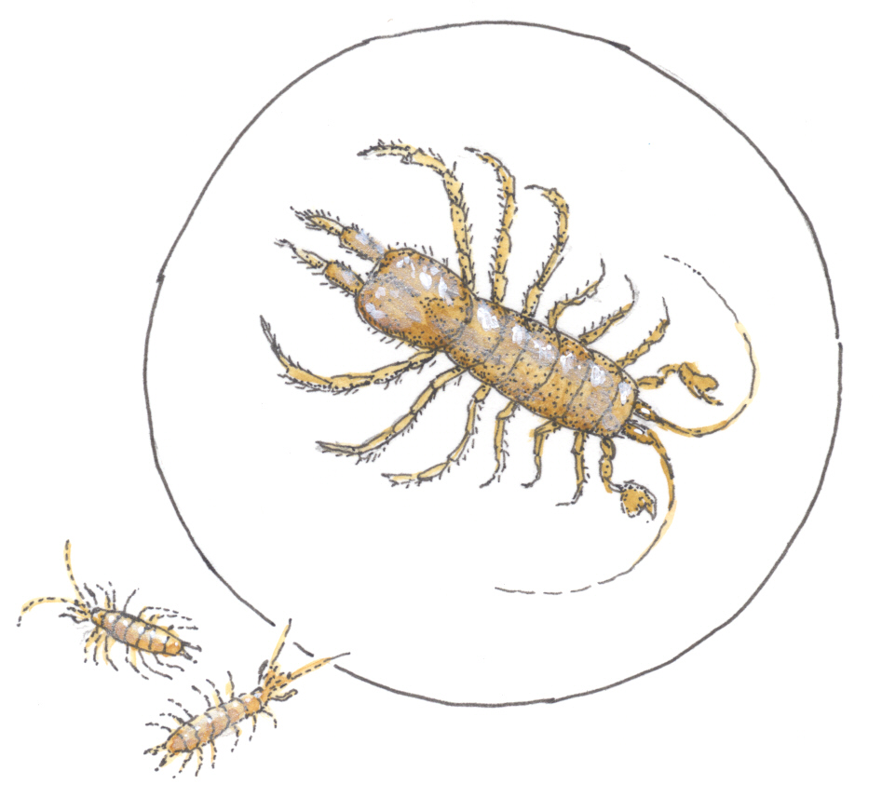  • are relatively easy to sample and identify.

Why We Need to Sample Macros | Human activities and natural events can change a watershed and interfere with the natural processes in a stream. By monitoring the aquatic macroinvertebrates in a stream we can learn about the quality of the water.

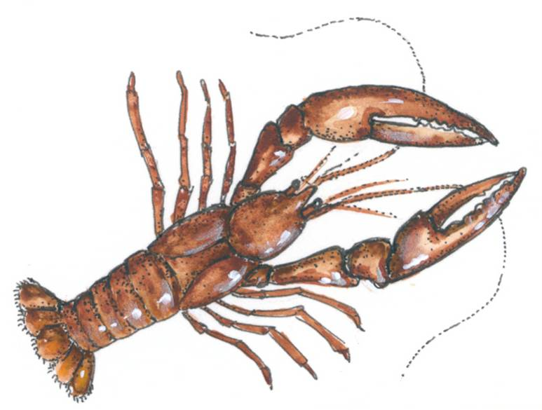  Rating Streams | 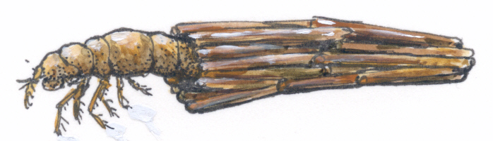  We rate streams according to the categories listed below:  Excellent: In a very healthy stream, there is a wide a variety of organisms (high biodiversity). Mayflies, stoneflies and case-making caddis flies are only found in good to excellent quality water. Less sensitive organisms may also be present.  Moderate: A moderately healthy site will have more pollution tolerant organisms, such as crayfish, dragonflies, crane flies, and snails. There will be fewer different species, and very few mayflies, stoneflies, and caddisflies.  Poor: Biodiversity will be low. The most common organisms will be pollution tolerant species, such as black fly larvae, worms, midge larvae and possibly leeches.
