Water Cycle
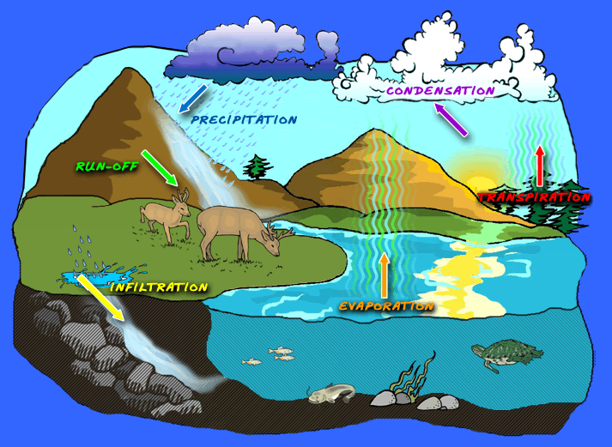
Water Cycle- The movement of water from the atmosphere to the earth and back to the atmosphere through precipitation, runoff, infiltration, percolation, storage, evaporation, and transpiration.

Precipitation- The force of gravity pulls water droplets or ice crystals (snow) down to the Earth’s surface.

Run-Off- When water moves along the top of the ground.

Infiltration- When rain hits the Earth’s surface and some of it sinks into the ground.

Evaporation-Energy from the sun changes liquid water into vapor, a gas.

Transpiration- Water enters plants through roots and moves into the plants and exits by evaporating through the leaves.

Condensation-Water vapor in the air travels as a gas until it meets cooler air where it changes back into water, snow or ice.

